DYING DINOSAUR DOLLARS FACE EXTINCTION
March 20, 2009 at 2:50 am | In .money matters, energy, gold |
Tags: bankruptcy, China, depression, Derivatives Beast, Federal Reserve, Free Trade, Germany, gold, Japan, JP Morgan, Russia, Treasury
EASY READING CULTURE OF LIFE NEWS: DYING DINOSAUR DOLLARS FACE EXTINCTION « Culture of Life News 2
Tonight, we will look at lots of Federal Reserve graphs. Anyone within this system who claims, ‘No body could see this coming,’ is just plain lying. The graphs show clearly how we had an increasingly unstable system even though ‘inflation’ was masked by various strategies, one of the biggest being, outright lying about real inflation. It is easy to pretend something doesn’t exist if you ignore it standing right in front of you. The Debt House of Cards has collapsed and our entire financial system has fallen. Totally. The world is desperate to pretend otherwise, but the two great imperial rivals, China and Russia, are now playing Chopin’s Funeral March. The dollar is doomed.
YouTube - Subway accordionist plays the Chopin Funeral March
This has to be the most wretched rendition of the famous Chopin piece. And is appropriate for this story! The collapse of the entire US financial system and the death of the dollar can be brought to the doorstep of one entity: the Federal Reserve. If ever there was a group of people practicing the dark arts of ‘hubris’, it is the people who created and then ran this system which systematically destroyed the dollar, it will not just lose 90% of its value but all of its value. Thank you, everyone.

Here is the death notice from the Federal Reserve:

FRB: Press Release–FOMC statement–March 18, 2009

Information received since the Federal Open Market Committee met in January indicates that the economy continues to contract. Job losses, declining equity and housing wealth, and tight credit conditions have weighed on consumer sentiment and spending. Weaker sales prospects and difficulties in obtaining credit have led businesses to cut back on inventories and fixed investment. U.S. exports have slumped as a number of major trading partners have also fallen into recession. Although the near-term economic outlook is weak, the Committee anticipates that policy actions to stabilize financial markets and institutions, together with fiscal and monetary stimulus, will contribute to a gradual resumption of sustainable economic growth.
Cancers grow. This is the definition of cancer: it grows until it kills the organism. The US attempts at ‘growth’ which excluded growing our manufacturing and trade businesses, has now collapsed. The ONLY things that grew was consumption and the money supply. The Fed could see this coming for a very long time, that is, ever since Nixon and Burns cut the gold peg to the dollar and the Floating Currency crime was perpetrated. The Fed thought it could control things via the interest rates. So it shot upwards until 1982.

Then, everyone switched gears and ‘free trade’ was born along with its crib mate, the Derivatives Beast. The fancy new computer program of the Bloomberg machine made it possible for everyone to play games with the obvious instabilities of the floating currency regime. Once everyone mastered all the possibilities of exploiting weaknesses and glitches in this fabulously impossible system to balance, they pushed the imbalances to their maximum extreme! And oops! It flipped over and died!

In light of increasing economic slack here and abroad, the Committee expects that inflation will remain subdued. Moreover, the Committee sees some risk that inflation could persist for a time below rates that best foster economic growth and price stability in the longer term.

HAHAHAHA. No inflation is evil in the Floating Currency Regime! We must have inflation! Keep adding those zeroes, damn it! Now! The insanity here is obvious: they talk about ‘price stability’ while grousing that we need MORE inflation! Inflation isn’t stable! Keeping it stable is very hard since everyone at the top benefits if they add zeroes like crazy to paper money! So they do it! DUH. Look at Zimbabwe.

After repeatedly creating all sorts of nasty bubbles that all have popped, the Fed should give up the business of ’stabilizing prices’ until they figure out why we had to have a gold basis to trade finances! This is very simple: gold limited inflation! If a country chose to have inflation, its currency would rapidly become worthless and all the gold would leave the banks and thus, no one would be able to lend. This is how money production is slowed. Not that the Fed doesn’t know this. They know this! But choose to ignore it.

St. Louis Fed: Series: TRARR, Board of Governors Total Reserves, Adjusted for Changes in Reserve Requirements
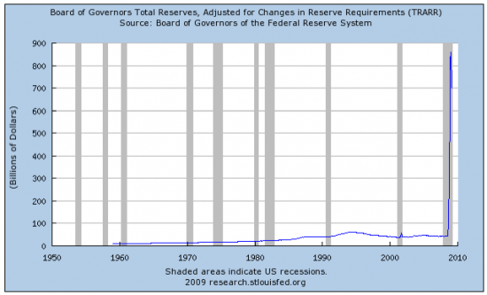
Here is the graph that shows how the Fed had to suck down all the Treasury debts, to the tune of nearly a trillion dollars, all in less than a year. Previous peaks, on this massive scale, have shrunk to tiny blips. This is a very bad graph and shows a collapse of the exterior banking system as well as the bond market for selling Treasuries.

St. Louis Fed: Series: BORROW, Total Borrowings of Depository Institutions from the Federal Reserve
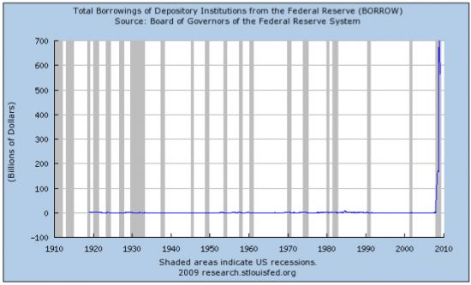
Everyone is borrowing from the Federal Reserve. Again, previous peaks that used to look really huge are now barely blips on the scale here as the amount reaches nearly a trillion, again, in less than a year. This is a total rip away from historic levels.
In these circumstances, the Federal Reserve will employ all available tools to promote economic recovery and to preserve price stability. The Committee will maintain the target range for the federal funds rate at 0 to 1/4 percent and anticipates that economic conditions are likely to warrant exceptionally low levels of the federal funds rate for an extended period.

The last Great Depression was long, too. Thanks, guys. And who helped create that mess? Take a wild guess! Here is a graph showing how the Fed bailed out AIG’s gnomes so they could yammer for more bonuses for messing up things so totally.

St. Louis Fed: Series: WAIG, Credit Extended to American International Group, Inc.
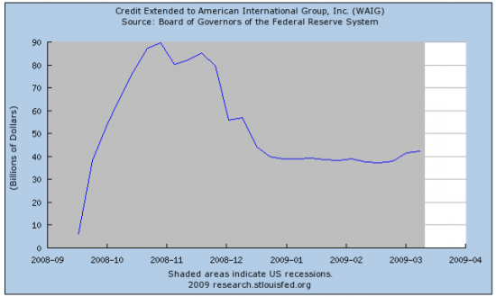
$100 billion to WAIG the dog’s tail!
To provide greater support to mortgage lending and housing markets, the Committee decided today to increase the size of the Federal Reserve’s balance sheet further by purchasing up to an additional $750 billion of agency mortgage-backed securities, bringing its total purchases of these securities to up to $1.25 trillion this year, and to increase its purchases of agency debt this year by up to $100 billion to a total of up to $200 billion. Moreover, to help improve conditions in private credit markets, the Committee decided to purchase up to $300 billion of longer-term Treasury securities over the next six months.

They will have to double the graphs to show this latest ‘purchase’. These ’securities’ are as secure as a sand dune in Galveston right before a category 5 hurricane hits! So, let’s add this all up: $750 billion in mortgages from bankrupt banks, mortgages that have to be paid by deadbeat home owners who got utterly reckless about debts plus another @200 billion in ‘agency debt’ and then another $300 billion in Treasuries that are not treasures at all, any more than British ‘gilts’ are gold. This equals what? $1.25 trillion? Good grief. Look at the losses from loans going bad:
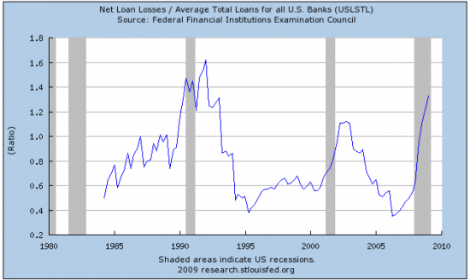
First big peak is in the Gulf War I financial collapse. Then, there was the smaller Dot Com failure. Now, the present mess has exceeded the 200-2002 collapse and is rapidly closing in on the 1990 mess.

The Federal Reserve has launched the Term Asset-Backed Securities Loan Facility to facilitate the extension of credit to households and small businesses and anticipates that the range of eligible collateral for this facility is likely to be expanded to include other financial assets. The Committee will continue to carefully monitor the size and composition of the Federal Reserve’s balance sheet in light of evolving financial and economic developments.
St. Louis Fed: FRED GRAPH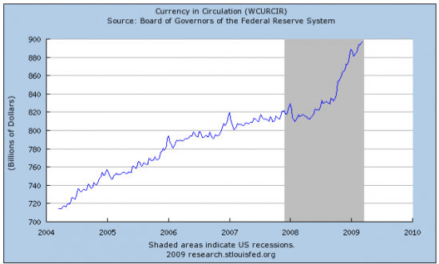

The last graph shows clearly how we have a lot more ‘money’ in circulation. Unlike the other graphs, this one goes up and up and up. I don’t see money disappearing. The value of assets are falling, but NOT the money supply. I got this ad in my email today. Look at the prices! List price of over half a million dollars and the starting bids are below $200,000? This is a $400,000+ differential! Talk about madness.


There is no way the Feds can ’stabilize’ this sort of readjustment short of killing the dollar, totally. And I fear, this is their insane plan! Only, it won’t work. Why, may we ask?

Simple! ONLY if we can have our incomes grow as fast or faster than Fed-induced inflation, can we buy these ‘cheaper’ houses, for example, and bid up the prices! Otherwise, forget it. The chief tool we use for this purpose is unionization or to prevent jobs from flowing to China, India and elsewhere. Ie: if we impose taxes and tariffs on all imports and prevent the exportation of labor. Then, we can devalue the dollar to our heart’s content. Of course, there is one teensy weeny problem here: we need to buy energy from outside of America! OOPS. This is where the news gets most interesting:

Mineweb - POLITICAL ECONOMY - Chinese Central Bank sees gold, oil and other resources recovering this year, but dubious on dollar
The prices of resource products from gold to crude oil are likely to see upward pressure later this year, while the outlook for the dollar is uncertain, China’s central bank said in a report issued on Friday.

The Dragon is being polite. What it is telling us is this: gold is going up, ergo, the dollar is worthless. Oops, can’t buy oil, either, eh? Imagine that. I predicted long ago, the Chinese would go ‘gold’ and this is due to their harsh past mistakes.

In its annual international financial markets report, the People’s Bank of China said it expected global demand to continue to weaken this year but held out the hope that the forceful policy response of governments could lead to a turning point in the world economic crisis.
“The international financial crisis will continue in 2009, and the world economic slowdown may continue. The global economic and financial situation faces huge complexity and uncertainty,” it said in the 147-page report.
“The measures taken by governments will gradually show their effects, and there may be a turnaround in the world economic and financial situation. The international financial markets are likely to warm up in the second half of this year.”
Let’s look at a Fed graph about the Japanese actions with dollars:

St. Louis Fed: Series: JPINTDUSDJPY, Japanese Intervention: Japanese Bank purchases of USD against JPY
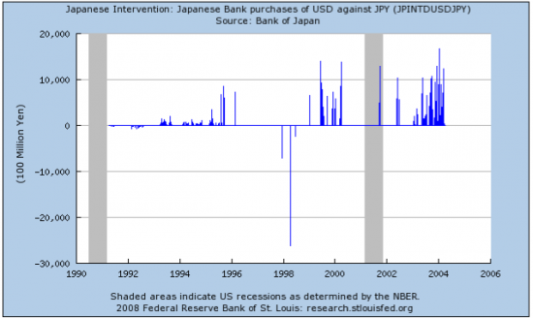
OK: Major sell-0ff at the beginning of the Great Asian Currency Crisis. I call this, the Great American Currency Crisis. Note that, for the most part, increasingly, Japan has intervened by making lots and lots of purchases, more and more. This is the Japanese Carry Trade trade mark.

Let’s look, for comparison, at the German money situation before the euro:

St. Louis Fed: Series: DEINTDEMS, German Intervention: Bundesbank Purchases in EMS Markets (Millions of DEM)
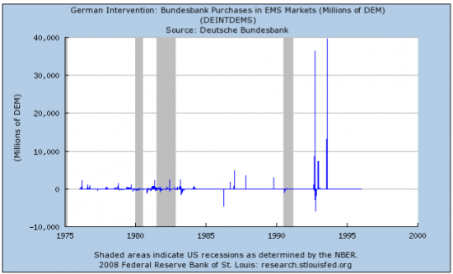
Small fluctuations until right before the euro was launched. The increasing instability led to the new currency and a New World Order which saw the euro overtake and overwhelm the dollar in FX markets.

RIA Novosti - Russia - Russia wants to start debate on new reserve currency at G20
Russia is proposing that discussions into the possibility of creating a new world reserve currency are initiated at the upcoming G20 summit in London, a government source said on Wednesday.

Russia is now the defacto head of OPEC when it comes to aggressive moves to restructure international finances. The Arab kings have very little political power due to deciding to be come fat little geese just aching to be eaten by hungry revolutionary radical foxes that circle silently, occasionally taking a severe bite and then hiding again, watching with eager eyes for revenge and great wealth.

“We fully agree that this is not the issue, which would enable us to get out of the crisis and cut costs. The main idea is to initiate discussions on this issue,” the government source said.
Russia earlier put forward a suggestion to the G20 summit which would see the IMF examining possibilities for creating a supra-national reserve currency, and also forcing national banks and international financial institutions to diversify their foreign currency reserves.
Russia has gold! Russia produces gold. Russia has gold mines. Russia loves gold and is itching to impose a gold regime on Europe. Europe was very stupid. To convince Americans, gold was useless, most of Europe’s banks divested themselves. Even, to my great shock, Switzerland. Throwing away over a thousand years of caution, they joined in this queer denial of reality.

St. Louis Fed: Series: PPICEM, Producer Price Index: Crude Energy Materials
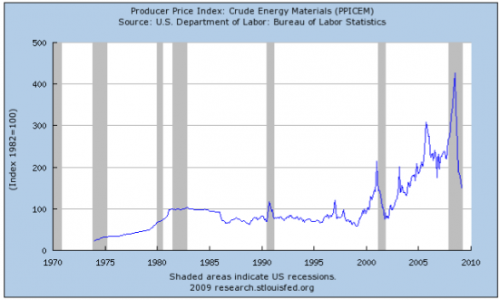

This graph is REAL SCARY. Crude energy materials are EXTREMELY UNSTABLE. The peaks are higher and higher. The drops are greater but the pause between peaks and valleys are all increasingly short time frames.

St. Louis Fed: FRED GRAPH
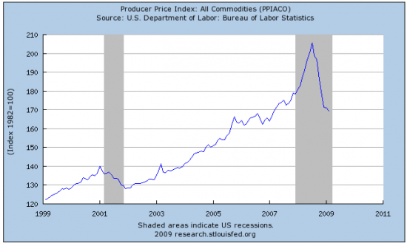
In the last 10 years, commodity prices have fallen each recession but mostly, have shot upwards right before recessions. This is, again, signs of increasing instability. And it came during a period, the Fed claimed, there was little to no inflation! Eh? I see lots of inflation. The 1982 dollar equalled 100 and at the peak, it equalled 205. This means, in 25 years, it doubled. This is called ‘inflation.’

YouTube - Funeral March—from Cuba [It turns out that “video is of the Cubatao martial (brass) orchestra/band. Cubatao is a city/district of the Sao Paolo-Santos conurbation in the state of Sao Paulo in Brazil”.]

U.N. panel says world should ditch dollar | U.S. | Reuters
A U.N. panel will next week recommend that the world ditch the dollar as its reserve currency in favor of a shared basket of currencies, a member of the panel said on Wednesday, adding to pressure on the dollar.

First, it was Iran. Then, some Arab kings groused about this and then retreated. Now, Russia is carrying this banner and here we are: the UN has decided it is time to talk about the dying dollar and maybe, bury it.

Currency specialist Avinash Persaud, a member of the panel of experts, told a Reuters Funds Summit in Luxembourg that the proposal was to create something like the old Ecu, or European currency unit, that was a hard-traded, weighted basket.

He has got to be kidding me. When we talk about weight, we are talking not about money with ‘X’ number of zeros. We are talking about HEAVY stuff. The usage of ancient words to describe things modern is funny, actually.

When I was hit by a lightning bolt, as a child, I saw and felt many things. One thing that terrified me and had me crying for help, was when I saw that a heavy rock weighed the same as a piece of paper. And this was also a blunt rock compared to a needle which weighed the same, even though it was small and shiny and the rock was huge and black.

Paper money has to be weighed by gold. This is the entire point of having paper money. Weighing paper with paper is a fool’s errand. For there is no true comparable value: there is nothing OUTSIDE the system to compare it to unless paper money is attached, as Putin suggested, to energy. Note, that he sells energy, of course.

Persaud, chairman of consultants Intelligence Capital and a former currency chief at JPMorgan, said the recommendation would be one of a number delivered to the United Nations on March 25 by the U.N. Commission of Experts on International Financial Reform.
“It is a good moment to move to a shared reserve currency,” he said.
The former pirate running JP Morgan doesn’t mind the dying dollar. He lives in a detached world where he flits about the planet, plotting with other Bilderberg lunatics. Arrest him. Now, for another graph:

St. Louis Fed: Series: BOPOG, U.S. Government Assets Abroad, Excluding Official Reserves, Net
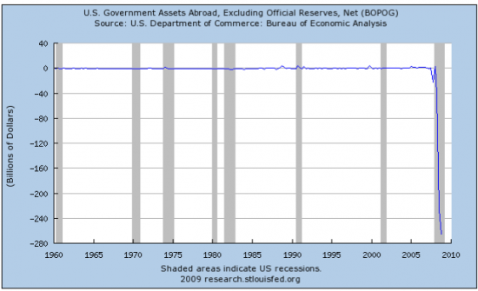

Minus $260 billion and DROPPING LIKE A ROCK. The paper is fluttering to the cellar along with the heavy rock. According to this graph, this has NEVER HAPPENED BEFORE!!! OK, NEVER!!!! This is a dead business. This is bankruptcy. This is a ‘waterfall’ incident with so many black swans swimming in the Dark Pool, we could be in a reverse Swan Lake ballet, eh?

Asia Times Online :: Asian news and current affairs
DOLLAR CRISIS IN THE MAKING, Part 1
Before the stampede
By W Joseph Stroupe Increasingly ominous clouds are gathering in what could soon be the perfect storm against the United States dollar and against the present dollar-centric global financial order.
This is not shaping up to be a storm that anyone is trying to initiate, not even those who are actively driving for a new global financial order that is no longer centered on the dollar. Instead, it will result from a correlation of forces arising out of the deepening global financial and economic crises, coupled with recurring and conspicuous miscalculation on the part of some of the world’s political, financial and economic leaders.
The storm has the potential to cause upheaval on a grand scale, opening the door to swift, and largely uncontrolled, fundamental transformation.
Foreign assets in the US [we are selling our souls and our futures] became greater and greater after Reagan’s rule. It shot down ONLY during global recessions. Then, it became a classing ‘hockey stick’ event and then REVERSED. It not only fell, it has fallen BELOW ZERO! Never, never has this happened before and look at how fast it happened! Wow.

St. Louis Fed: Series: BOPIP, Other Foreign Assets in the U.S., Net
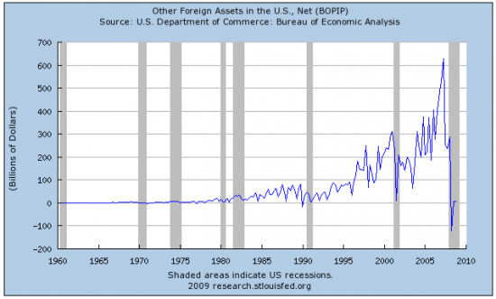
This is the reverse of the above boomerang.

St. Louis Fed: Series: BOPO, U.S. Assets Abroad, Net: Outflow (-)
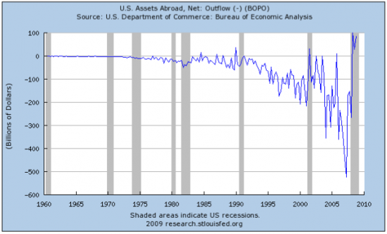
Our trade situation has been a total catastrophe since the dollar was cut from the gold peg. Nixon thought, this would save us. It doomed us.
St. Louis Fed: Series: BOPBCA, Balance on Current Account
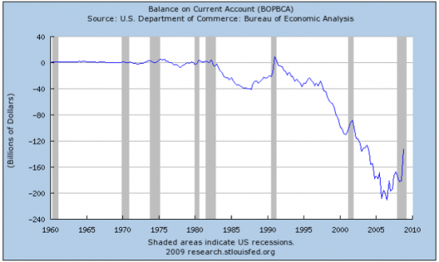
WORLD OF TROUBLE - New York Post
The investors that own many of the derivative securities at the center of American International Group’s collapse are among the world’s and this country’s biggest investors, sources told The Post. People familiar with the matter said buyers of AIG Financial Products’ derivatives, which consist mostly of collateralized debt obligations tied to mortgages, include Middle Eastern sovereign-wealth funds and the Chinese and Indian governments, which are also among the biggest holders of US Treasury securities. Exactly how much AIG has in derivative exposure is subject to debate. While AIG’s beleaguered CEO Ed Liddy told a House subcommittee yesterday that the insurer’s exposure is around $1.6 trillion, others have dismissed that figure as not reflecting actual losses.
The AIG mess keeps getting worse and worse. I remember when Lehman collapsed. Everyone assured us, the Derivatives Beast was really very, very small and the crash would have virtually no repercussions. Well, the Beast is eating us all up and they still deny this? How charming. Arrest everyone and charge them with treason.
ΩΩΩΩΩΩΩΩΩΩΩΩΩΩΩΩΩΩΩΩΩΩΩΩΩΩΩΩΩΩΩΩΩΩΩΩΩΩΩΩΩΩΩΩΩΩΩΩΩΩΩΩΩΩΩΩΩΩΩΩ
EMAIL ADDRESS:
emeinel@fairpoint.net
MAILING ADDRESS:
EMS NEWS
P.O. BOX 483
BERLIN, NY 12022
Make checks out to ‘Elaine Supkis’
CLICK HERE
TO DONATE TO THIS WEBSITE

